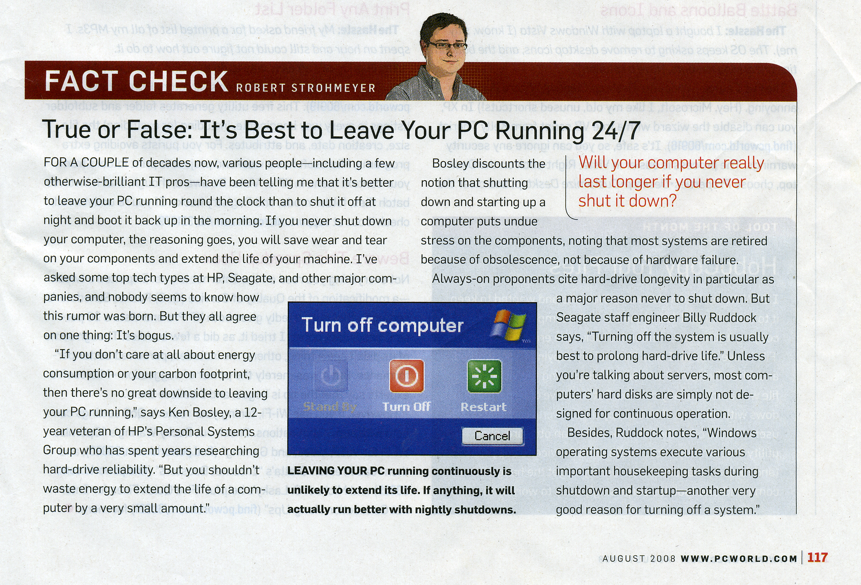
- Is it best to leave your pc running 24/7? Why or why not? (Delete the above image of the article to make the file smaller and quicker to upload. Make sure to put your name on this Word document. Be sure to use the appropriate file name - see syllabus for directions.)

